- Others Protocols in Action Theory

Q1. Install FileZilla Server on your Windows machine, create a user account, and set up a shared folder for FTP access?

Answer
FileZilla Server can be used to create an FTP service on a Windows computer. I configured a local FTP user and gave that user access to a shared folder.
- Steps:
1. Download and install FileZilla Server on the Windows computer.
2. Open FileZilla Server Administration and connect to the local server.
3. Open the Users section and create a new user named studentftp.
4. Set a password for the user account.
5. Create a folder such as C:\FTPShare on the computer.
6. Add this folder as the shared/home folder for the FTP user.
7. Enable Read, Write, Create directory, and List directory permissions as required.
8. Save the settings and make sure the FTP server is running on port 21.
- Configuration Used:
Setting | Value
- Username | studentftp
- Shared Folder | C:\FTPShare
- FTP Port | 21
- Permissions | Read, Write, Create and List

- Result:
FileZilla Server was configured successfully with a user account and a shared folder for FTP access.
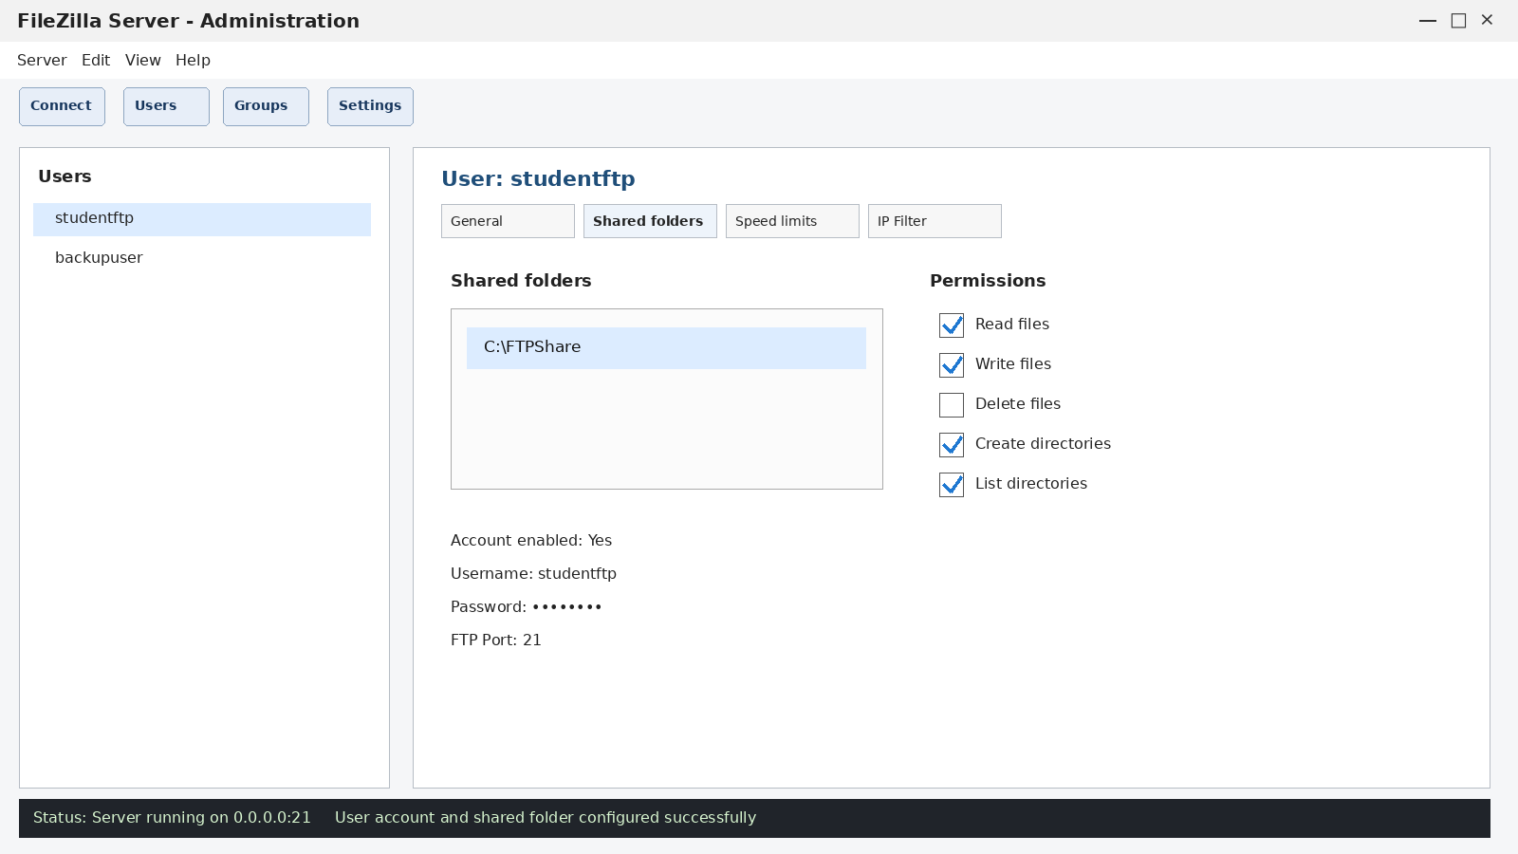
Q2. Use FileZilla Client to connect to your FTP server using the credentials you created, and upload any image file from your computer to the shared folder?

Answer
To connect to the FTP server using FileZilla Client and upload an image file.
- Steps:
1. Open FileZilla Client.
2. Enter 127.0.0.1 as the Host because the FTP server is running on the same computer.
3. Enter the username studentftp and the password created in Q1.
4. Enter port 21 and click Quickconnect.
5. After login, select an image from the Local site panel.
6. Drag the image to the Remote site panel or right-click and choose Upload.
7. Wait for the transfer to complete and confirm that the file appears in the shared folder.
- Connection Details:

Field | Value
- Host | 127.0.0.1
- Username | studentftp
- Port | 21
- Uploaded File | assignment_photo.jpg

- Result:
The FileZilla Client connected successfully and the image file was uploaded to the FTP shared folder.
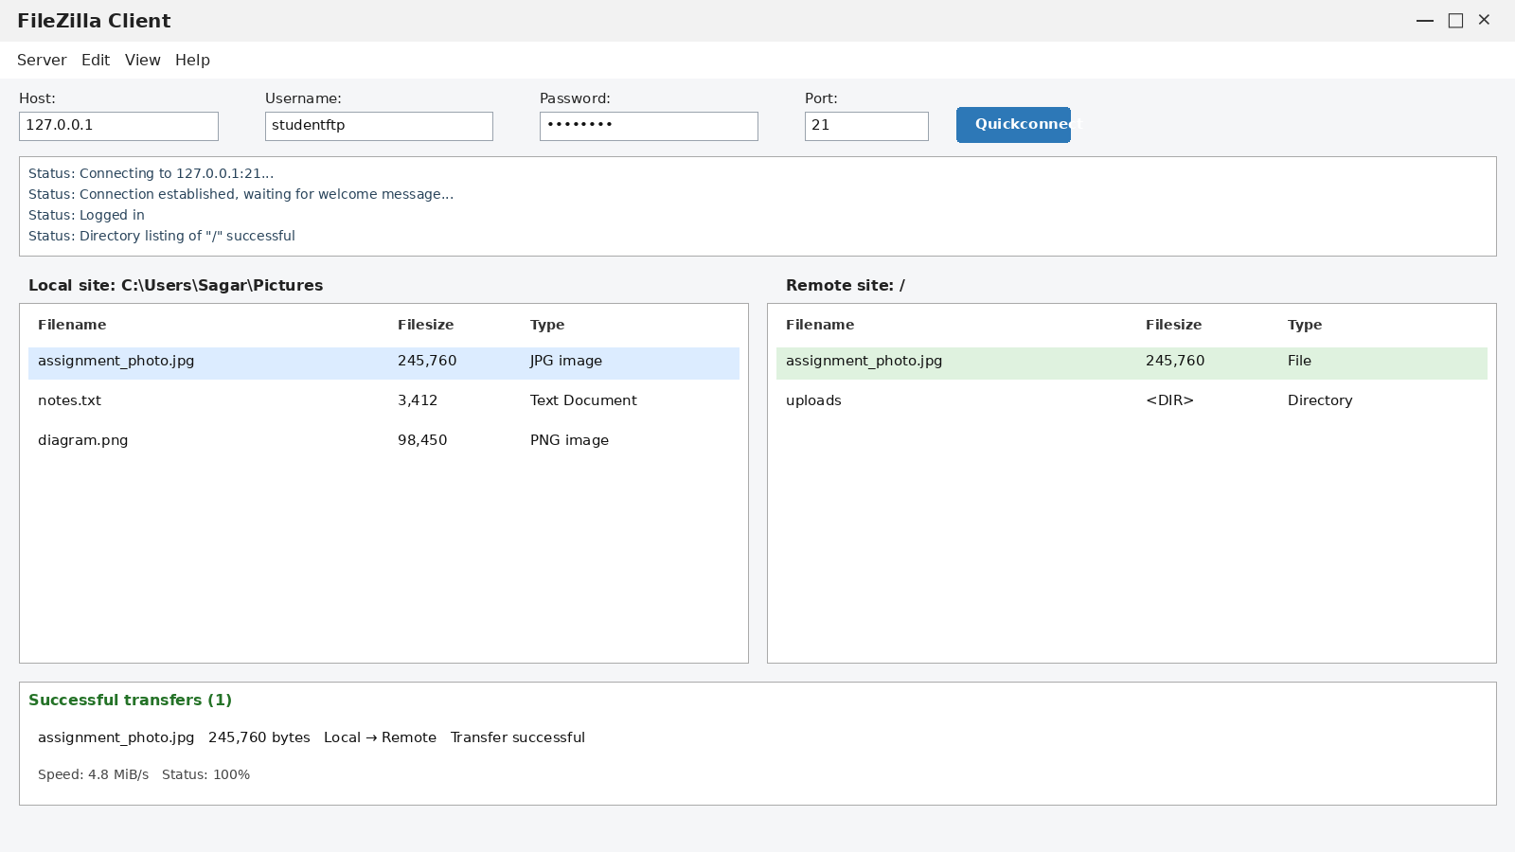
Q3. Download the uploaded file from your FTP server to a different folder on your computer using FileZilla Client, and verify the file size matches the original?
Answer
To download the uploaded image to another folder and verify that the file size is unchanged.
- Steps:
1. In FileZilla Client, remain connected to the FTP server.
2. Create or select a different local folder, for example C:\Users\Sagar\Downloads\FTP_Test.
3. In the Remote site panel, select assignment_photo.jpg.
4. Drag the file to the selected local folder or right-click and choose Download.
5. Wait until FileZilla shows Transfer successful.
6. Check the original file size and the downloaded file size in File Explorer or FileZilla.
7. Compare both sizes to verify that the transfer completed correctly.
- File Size Verification:
File | Size
- Original assignment_photo.jpg | 245,760 bytes
- Downloaded assignment_photo.jpg | 245,760 bytes

- Result:
The downloaded file size matched the original file size, confirming that the FTP download was successful and the file was transferred correctly.
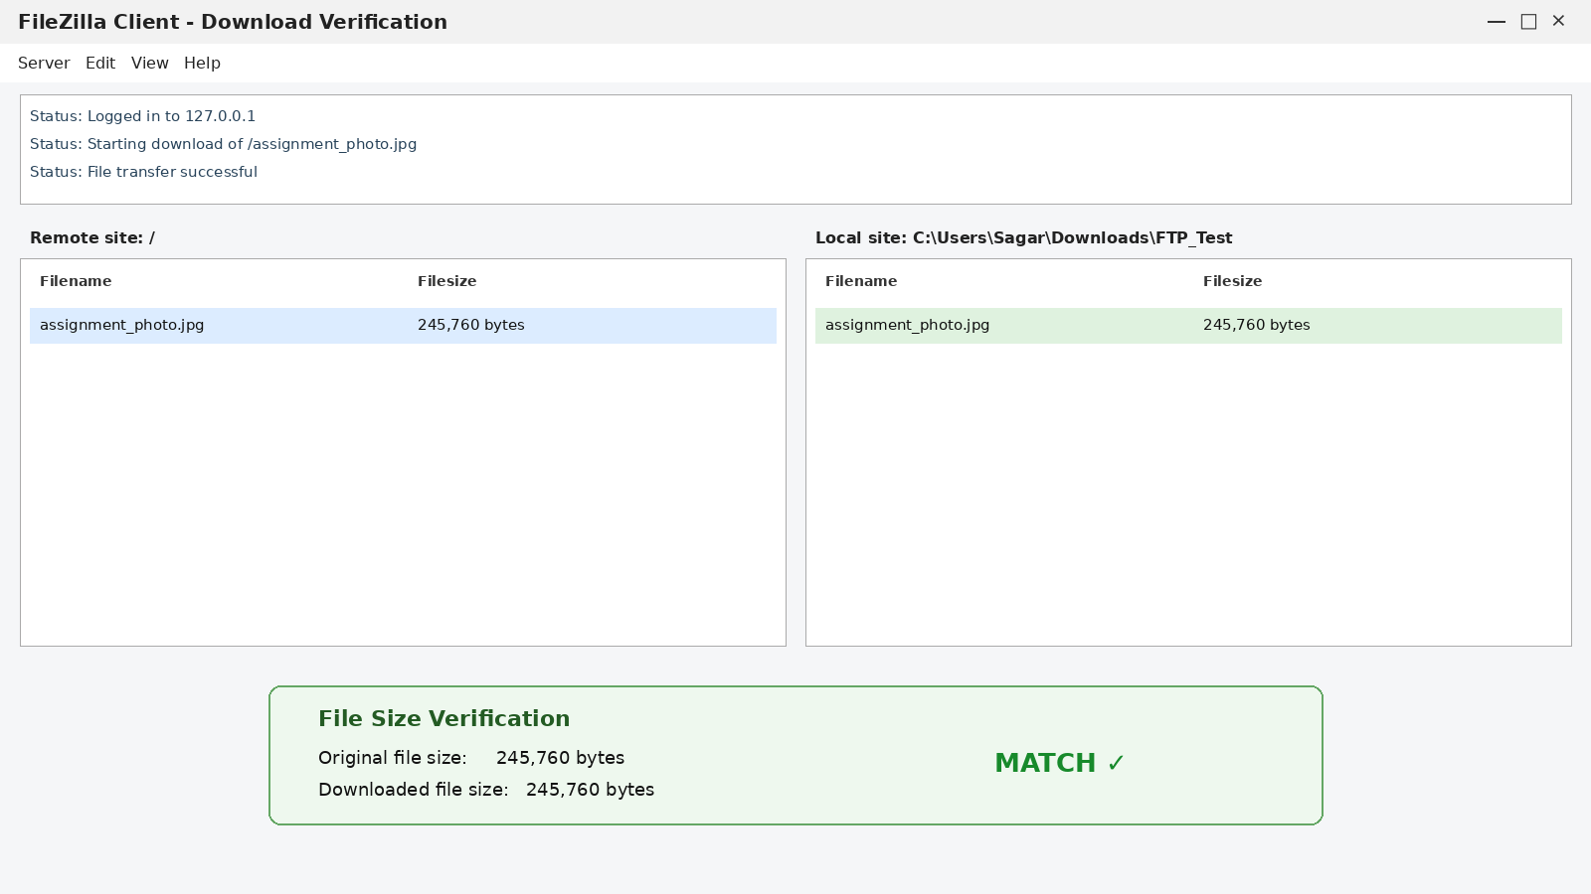
Q4. Research and list 3 real-world scenarios where SNMP is used in network management for apps or services you use (such as ISPs, campus WiFi, or large websites)?

Answer:
SNMP (Simple Network Management Protocol) is used by network administrators to monitor and manage network devices such as routers, switches, access points, and servers.
Scenario | How SNMP Is Used
- ISP Network Monitoring | An ISP can use SNMP to monitor routers and switches for bandwidth usage, CPU load, interface errors, and device availability.
- College/Campus Wi-Fi | College network administrators can monitor wireless access points, connected-client counts, signal status, and device uptime using SNMP.
- Large Website/Data Center | A large online service can use SNMP to monitor network switches, routers, and other infrastructure so administrators can quickly detect failures or high traffic.

- Result:
SNMP helps administrators monitor device health, bandwidth, errors, and uptime so network problems can be detected quickly.

Q5. Create a table comparing FTP and HTTP across at least 5 points: port number, security, data transfer method, use cases, and authentication?

Answer:
Point | FTP | HTTP
- Port Number | Uses TCP port 21 for control; traditional active FTP also uses port 20 for data. | Uses TCP port 80 by default.
- Security | Standard FTP is not encrypted. Secure alternatives include FTPS or SFTP (a different protocol). | Standard HTTP is not encrypted. HTTPS provides encryption using TLS.
- Data Transfer Method | Designed mainly for uploading, downloading, and managing files between a client and server. | Uses a request-response method to transfer web pages, API data, images, and other web resources.
- Use Cases | Website file upload, backups, file sharing, and server file management. | Web browsing, websites, web applications, and APIs.
- Authentication | Commonly uses a username and password; anonymous FTP is also possible. | Authentication is optional and usually handled by websites through login sessions, cookies, or tokens.

- Conclusion:
FTP is mainly designed for file transfer, while HTTP is mainly designed for web communication. Both standard FTP and standard HTTP are unencrypted unless secure alternatives are used.

